Looker

This section explains how to connect Looker to an Exasol database.

Looker is a business intelligence software and big data analytics platform that helps you explore, analyze, and share real-time business analytics easily. Looker is a web-based application and connects to Exasol using JDBC.

For more information about Looker, refer to the [**Looker Documentation**](https://docs.looker.com/).

Exasol takes no responsibility for any changes in functionality or terms of use for the third-party software described in this section. For more information, refer to the respective software vendor’s website.

**Prerequisites**

* Ensure right permissions are provided to users to access Exasol. For more information, refer to [**Exasol**](https://docs.looker.com/setup-and-management/database-config/exasol) section in the Looker documentation.
* Exasol database running.

**Connect Looker to Exasol**

Follow these steps to create a connection to Exasol on Looker:

1. Open Looker in your browser using the Looker URL for your organization and login with your credentials. The Looker landing page is displayed, as shown below.

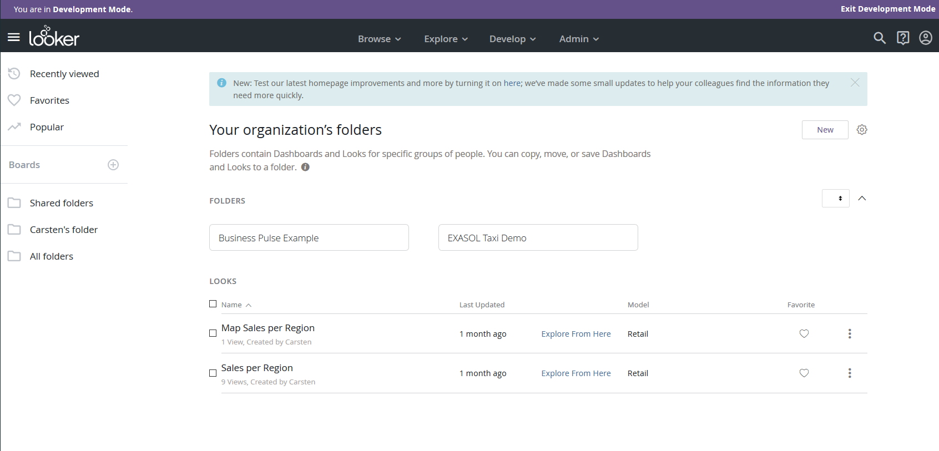

1. From the top panel, click **Admin** and under **Database**, select **Connections**.

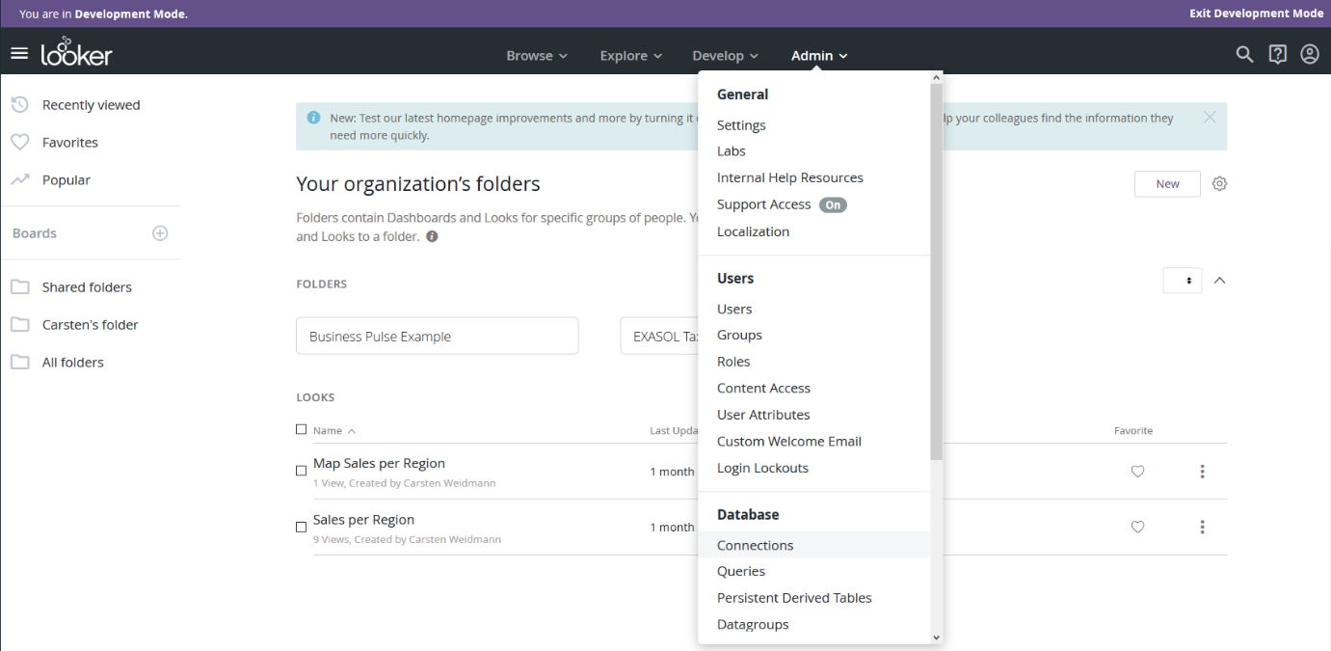

1. In the Connections screen, click **New Connection** to add a new connection.

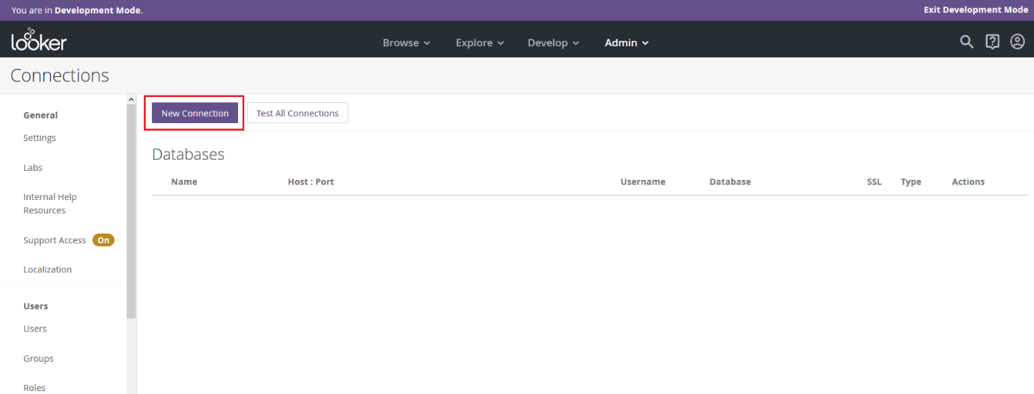

1. At the top of the **New Connection** screen, you have two options to configure the connection. Select the option **Existing Database** to configure a Looker connection to a current database or select the option **New Database** to create, connect, and download your data into a new Looker database. In this guide, we have chosen the option **Existing Database**.
2. Enter the connection details for the following fields in the**New Connection** screen:
   * **Name:** Name to identify the connection.
   * **Dialect:** Choose Exasol from the drop-down list.
   * **Host:Port:** The database hostname and port number that Looker should use to connect to your database.
   * **Database:** Your Exasol database name.
   * **Username:** Enter the user name to connect to the database.
   * **Password:** Enter the password to connect to the database.
   * **Schema:** The default schema Looker must use.
   * **Persistent Derived Tables:** Select this checkbox to enable persistent derived tables. This reveals the Temp Database, which is a dedicated schema in the database to store persistent derived tables.
   * **Temp Database:** Schema name Looker must use to create persistent derived tables (for example, LOOKER_SCRATCH).
   * **Additional Params:** You can include additional Java Database Connectivity (JDBC) parameters for your queries here if needed.
   * **PDT and Datagroup Maintenance Schedule:** You can provide a Cron expression that indicates Looker on how often should a check for datagroups and Persistent Derived Tables be regenerated or dropped. The default value is */5****, which means 'check every 5 minutes', and this is the maximum frequency of checks.
   * **SSL:** Choose whether or not you want to use SSL encryption to protect data.
   * **Max Connections:** Set the maximum number of connections that Looker can establish with your database.
   * **Connection Pool Timeout:** Enter the maximum amount of time a request will wait before the connection times out.
   * **SQL Runner Precache:** Select the checkbox to pre-cache table. This allows all table information to be pre-loaded as soon as you select a connection and schema, and faster display of table columns when you click on a table name.

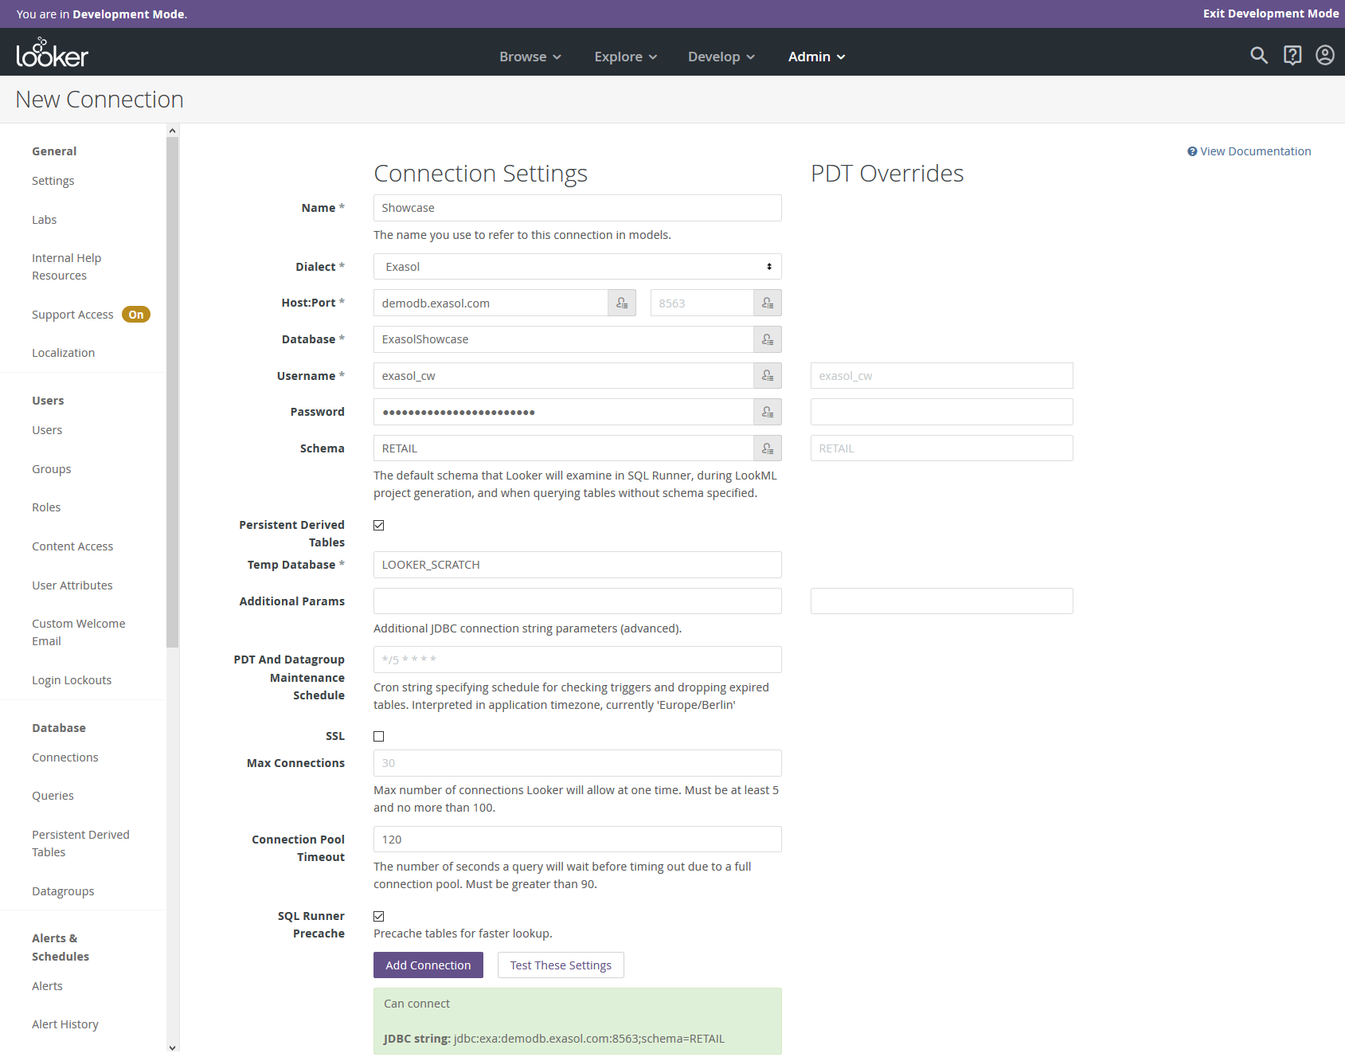

1. To test the connection to Exasol, click **Test These Settings**.
2. To save the connection, click **Add Connection**.

**View Connection**

Once you have configured the Looker connection, you can view the connection on the Connections screen as shown below:

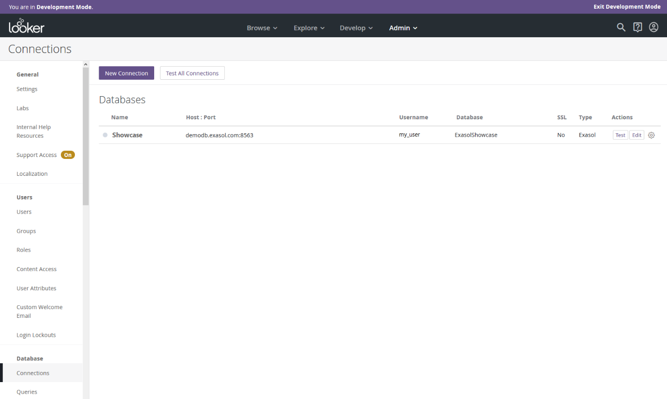

Once you have configured the connection to Exasol, you can next create dashboards and reports. For more information on how to create dashboards, see [**Looker Documentation**](https://docs.looker.com/).

**Looker integration**

* Article
* 03/30/2023
* 7 contributors

Feedback

**In this article**

1. [How to enable Looker integration](https://learn.microsoft.com/en-us/viva/goals/looker-integration#how-to-enable-looker-integration)
2. [How to configure the Looker connection](https://learn.microsoft.com/en-us/viva/goals/looker-integration#how-to-configure-the-looker-connection)
3. [How to connect the Looker integration to an OKR](https://learn.microsoft.com/en-us/viva/goals/looker-integration#how-to-connect-the-looker-integration-to-an-okr)

Viva Goals Looker integration enables automated real-time tracking of objectives and key result (OKR) progress.

Consider this example: You maintain sales reports in Looker dashboards. You have an objective to achieve 50 sales demos within a specific time period. You use Looker integration to set up a connection to an OKR in Viva Goals with a *demos booked* metric. Viva Goals automatically syncs the values for you and charts your progress toward the goal. This strategy saves you time while keeping your OKRs current.

**How to enable Looker integration**

A Viva Goals admin follows these steps to enable Looker integration in Viva Goals:

1. Go to the Viva Goals integrations page: **Admin** > **Integrations**.

[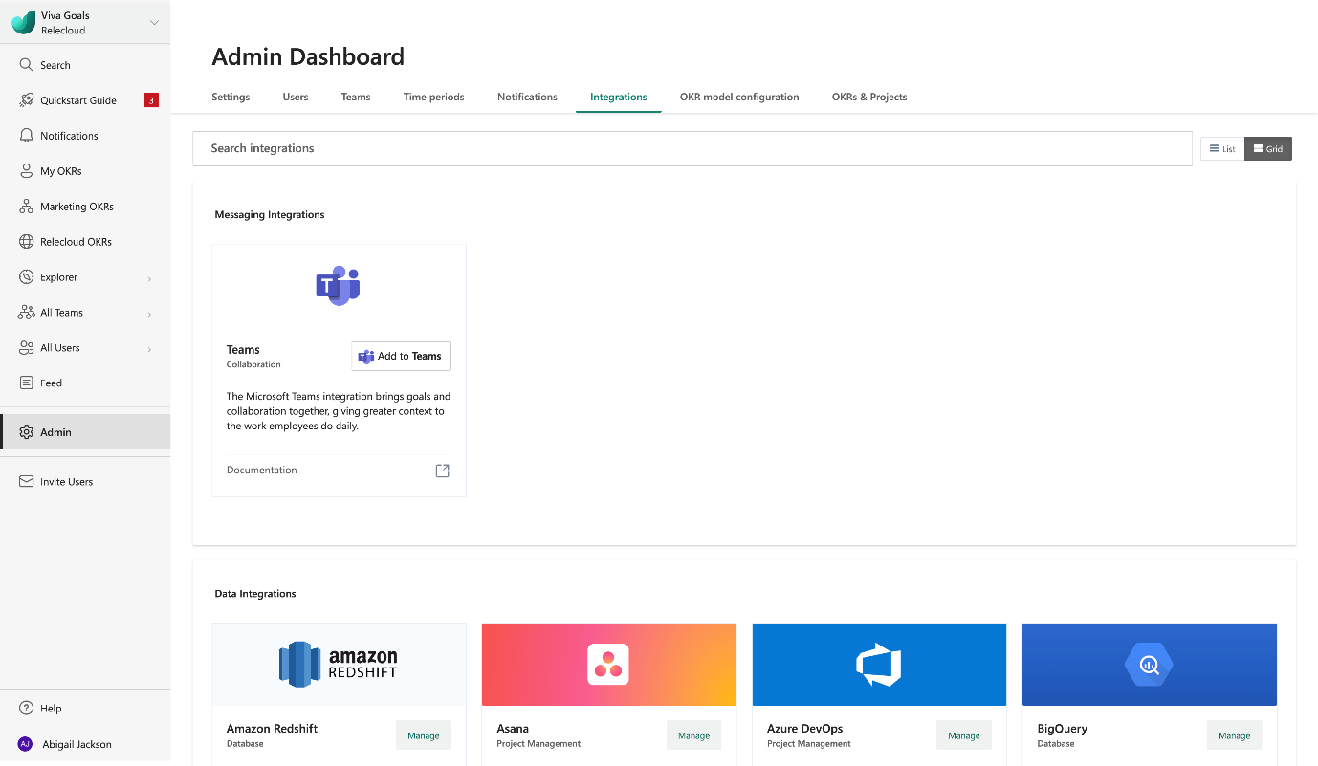](https://learn.microsoft.com/en-us/viva/media/goals/6/viva-goals-integrations-page.png#lightbox)

1. Scroll through the list until you reach **Looker**. Select **Enable** (or select **Manage** if a connection was previously made).

[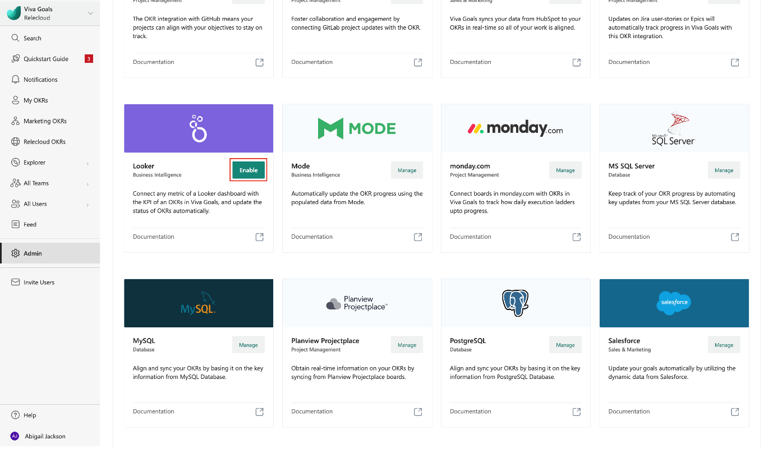](https://learn.microsoft.com/en-us/viva/media/goals/6/looker-enable-button.png#lightbox)

You can also disable the integration at any time from the same section.

[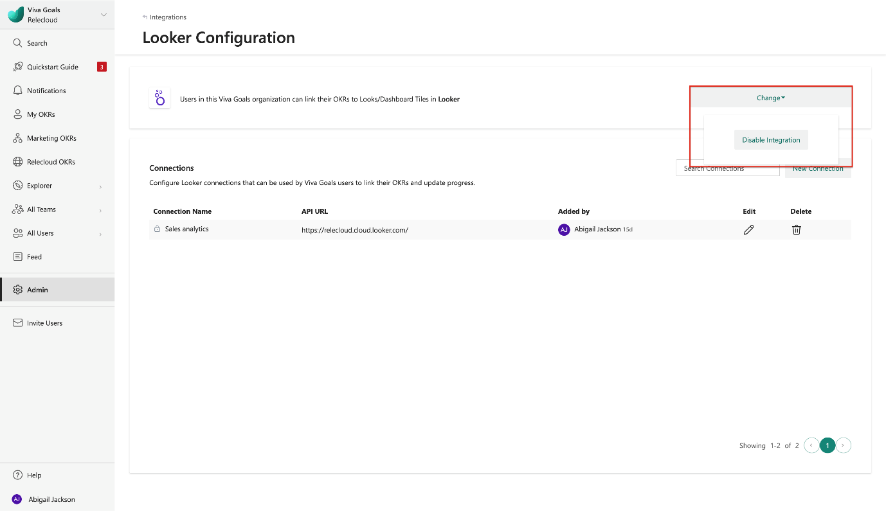](https://learn.microsoft.com/en-us/viva/media/goals/6/looker-disable-button.png#lightbox)

**How to configure the Looker connection**

In the **Connections** section, select **New Connection**. In the dialog that appears, enter the name of the connection and the application programming interface (API) that you get from your Looker administrator. You can optionally choose to share the connection with other users in the organization and select **Save**. You can also edit the saved connection at any time.

[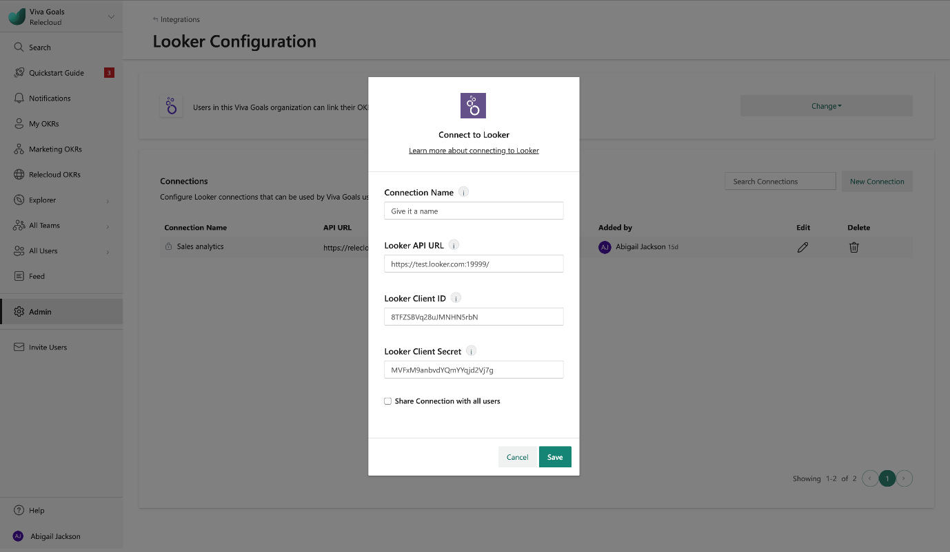](https://learn.microsoft.com/en-us/viva/media/goals/6/looker-configure-new-connection.png#lightbox)

**How to connect the Looker integration to an OKR**

Once setup is complete, users in your organization can link their OKRs to Looker dashboards and looks.

1. When you create (or edit) an OKR, select **Connect data source to auto-update progress**.
2. From the list of integrations, select **Looker**.

[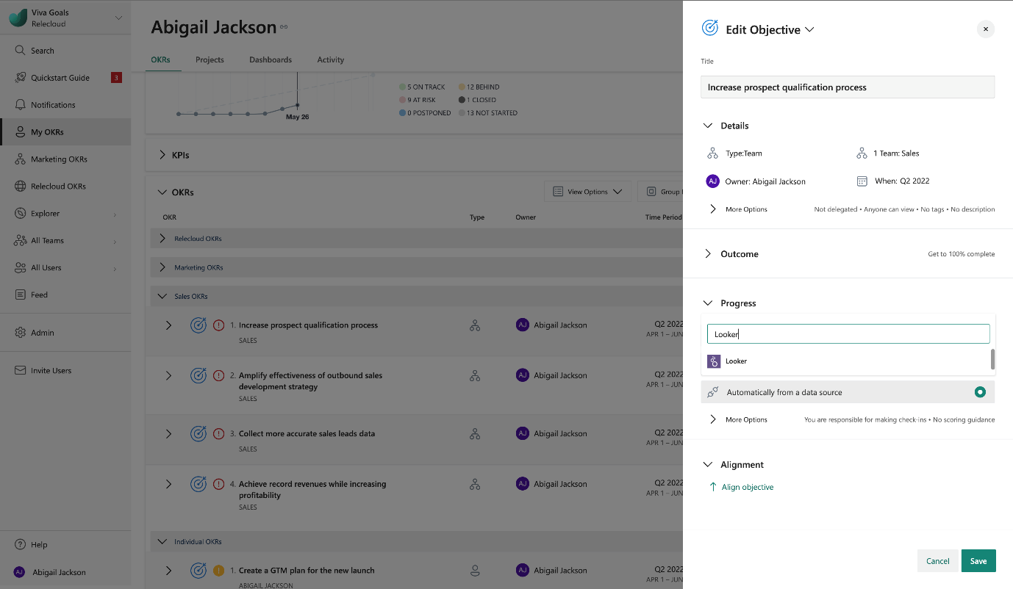](https://learn.microsoft.com/en-us/viva/media/goals/6/looker-datasource.png#lightbox)

1. If you already created a Looker connection, or an administrator in your organization shared a Looker connection with you, that connections will automatically be selected. If there are no connections already created or shared, Viva Goals will prompt you to add a new connection. If you have more than one Looker connection, you can choose the connection you’d like to use.

**Note**

The Looker integration is available only for the *KPI (success metric)* method of measuring OKR success. It's not available for the *% completion* method.

1. After you select the connection, you can choose to **Track KPI from** either a dashboard or a look. After you choose a dashboard or a look, you can further narrow it down to a specific dashboard tile or a look name. Select the tile or look that has the data you want to be connected to the OKR.

[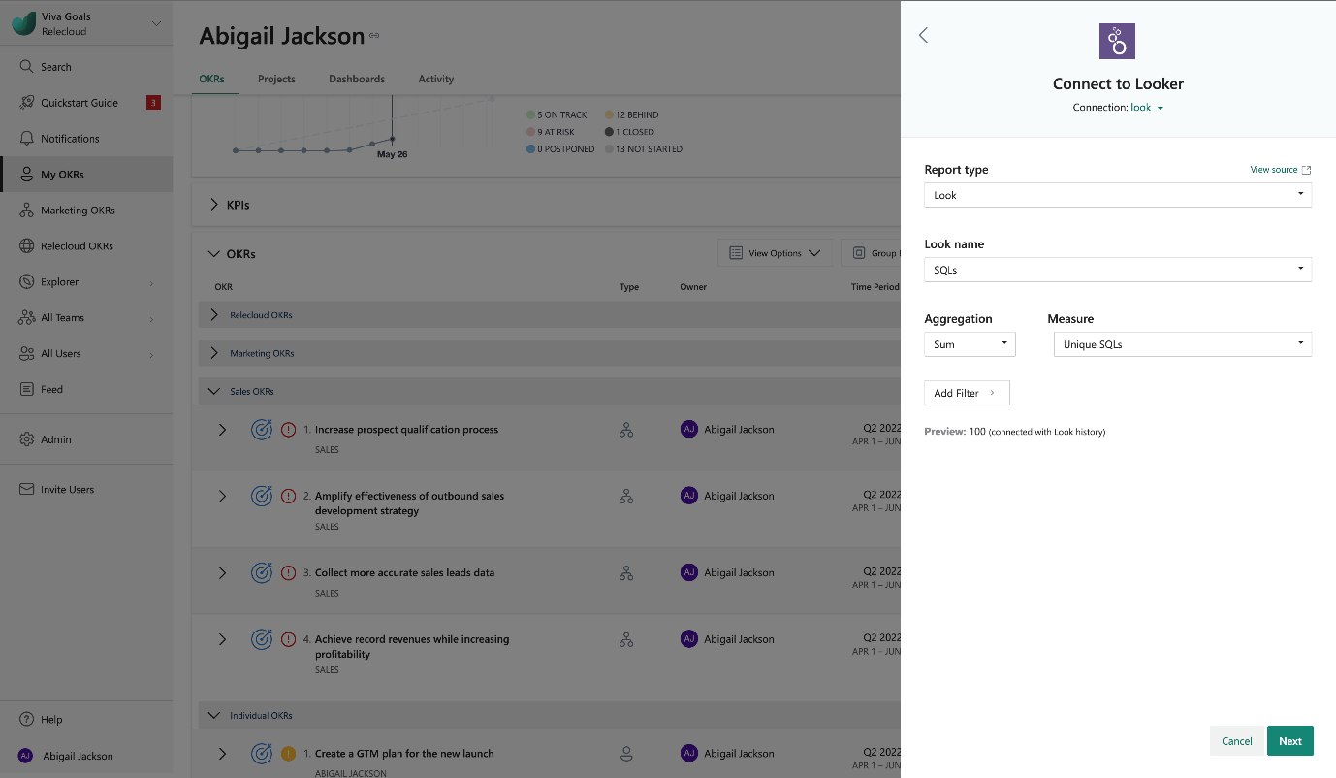](https://learn.microsoft.com/en-us/viva/media/goals/6/looker-connection-details.png#lightbox)

1. Select a KPI metric that's available from the selected tile or look. Depending on the type of visualization, there could be multiple values for the KPI, broken down by a dimension. For example, if you have the demos setup metric broken down by your sales team members as part of the Looker tile, you can choose to apply a metric/sum/average/count on the set of values or filter out by a particular person or any available filter field.

Viva Goals displays the selected value for your reference before you save the data link setup.

1. When you're satisfied, select to **Save** your OKR. You should now see a Looker icon next to the OKR. Viva Goals will automatically count the finished number of demos set up. The OKR syncs automatically every hour. Or, to refresh it manually, go to the Looker icon and select the **Sync Now** option.

The following colors of the progress bar indicate the status of the objective:

* If the progress is 0 to 25 percent less than expected progress at any time, the status is *behind* (orange).
* If the progress is more than 25 percent less than expected at any time, the status is *at-risk* (red).